WEEK-6

**3. ReactJS-HOL**

Create a react app for Student Management Portal named scorecalculatorapp and create a function component named “CalculateScore” which will accept Name, School, Total and goal in order to calculate the average score of a student and display the same.

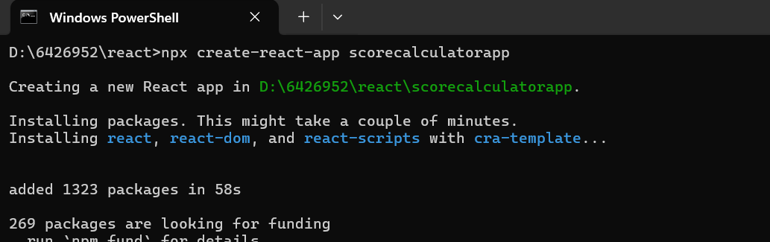

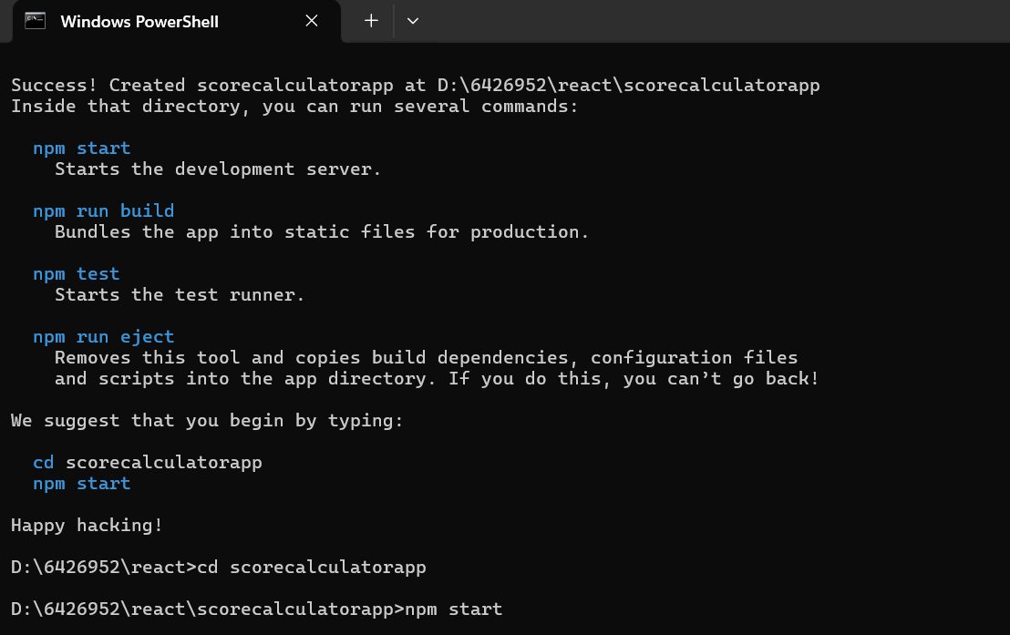

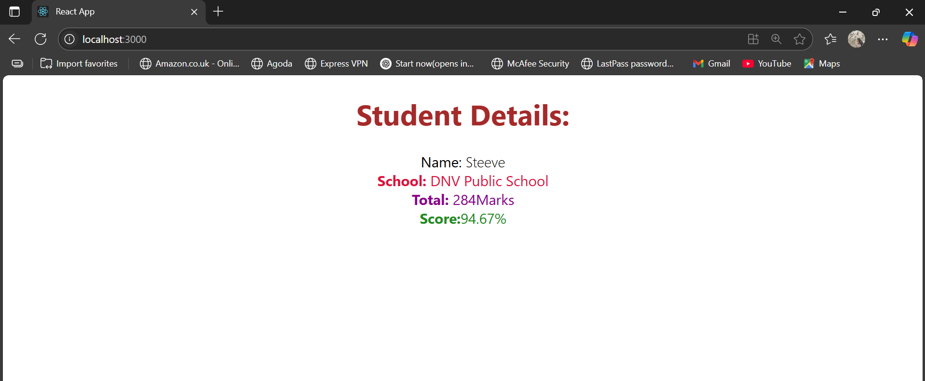

**CalculateScore.js:**import './Stylesheets/mystyle.css'

const percentToDecimal = (decimal) => {

    return (decimal.toFixed(2) + '%')

}

const calcScore = (total,goal)=>{

    return percentToDecimal(total/goal)

}

export const CalculateScore = ({Name,School,total,goal})=>{

    return(

    <div className="formatstyle">

        <h1><font color="Brown">Student Details:</font></h1>

        <div className="Name">

            <b><span>Name: </span></b>

            <span>{Name}</span>

        </div>

        <div className="School">

            <b><span>School: </span></b>

            <span>{School}</span>

        </div>

        <div className="Total">

            <b><span>Total: </span></b>

            <span>{total}</span>

            <span>Marks</span>

        </div>

        <div className="Score">

            <b>Score:</b>

            <span>

                {calcScore(

                    total,

                    goal

                )}

            </span>

        </div>

    </div>

    )}

**mystyle.css:**  
.Name{

    font-weight: 300;

}

.School{

    color: crimson;

}

.Total{

    color: darkmagenta;

}

.formatstyle{

    text-align: center;

    font-size: large;

}

.Score{

    color: forestgreen;

}

**App.js:**  
import { CalculateScore } from './Components/CalculateScore';

function App() {

  return (

    <div>

      <CalculateScore Name={"Steeve"}

      School={"DNV Public School"}

      total={284}

      goal={3}

      />

    </div>

  );

}export default App;